

A New Paradigm for Climate Science: CO₂ is Innocent!

Scientists Ned Nikolov and Karl Zeller have a unique and extremely elegant research paper currently in press entitled ‘New Insights on the Physical Nature of the Atmospheric Greenhouse Effect Deduced from an Empirical Planetary Temperature Model’. Their work comes out of left field; it provides a shocking new paradigm heretofore unbeknown to science; it is physically plausible, and it proves beyond a doubt that greenhouses gases cannot cause in principle the global warming observed since 1850. In other words, we all now have scientific proof that humans are not responsible for climate change on Earth. However, the problem is that both believers and deniers of the anthropogenic climate change have a hard time accepting the Nikolov-Zeller discovery, because the proposed mechanism (supported by NASA planetary data) was not taught in school. In addition, their adopted macro-level (top-down) approach does not explicitly include processes such as radiant heat trapping by free atmospheric trace gases assumed a priori to be true for 190 years. The Nikolov-Zeller article points to the fact that fundamental theoretical misconceptions can still occur in science despite the high-technology information environment of the modern world.
Rather than argue about global temperature trends or what the sensitivity of Earth’s climate to a CO₂ increase might be, Nikolov and Zeller decided to go back to the basics taking an inspiration from Copernicus, who propose the revolutionary heliocentric model of the Solar System that was later mathematically proven by Johannes Kepler. Nikolov and Zeller divined three fundamental questions that most climate scientists do not consider worth asking or thinking about:

- What would the mean global temperatures () of the rocky planets Venus, Earth, Mars, and the moons Triton and Titan be if they didn’t have atmospheres?

- Might the same physical principles determine the global temperatures () of Venus, Earth, Mars, Titan and Triton? In other words, is Earth a special case in terms of its climate, or is it a part of cosmic physical continuum?

- What are the fundamental controllers of the long-term average equilibrium global temperature of any planet or moon?

Analyzing vetted NASA data from various space exploration missions conducted over the past three decades, Nikolov and Zeller found that the Earth’s 30-year equilibrium surface temperature is quite stable and fully explainable in the context of an interplanetary physical continuum. As unbelievable as it may sound, they discovered that one can simply use extraterrestrial data from Venus, Moon Mars and Triton to predict the 30-year mean global surface temperature of Earth with an error of only 1ºC! This accurate prediction is done knowing just two Earth parameters: the total surface air pressure and our planet’s distance to the Sun. Amazingly, as it turns out, their model (empirically derived from NASA data) does not need any information about atmospheric composition, i.e. the amounts of greenhouse gases, to reliably calculate Earth’s mean global temperature! The Figure below encapsulates the new finding (model) by Nikolov & Zeller (2017):

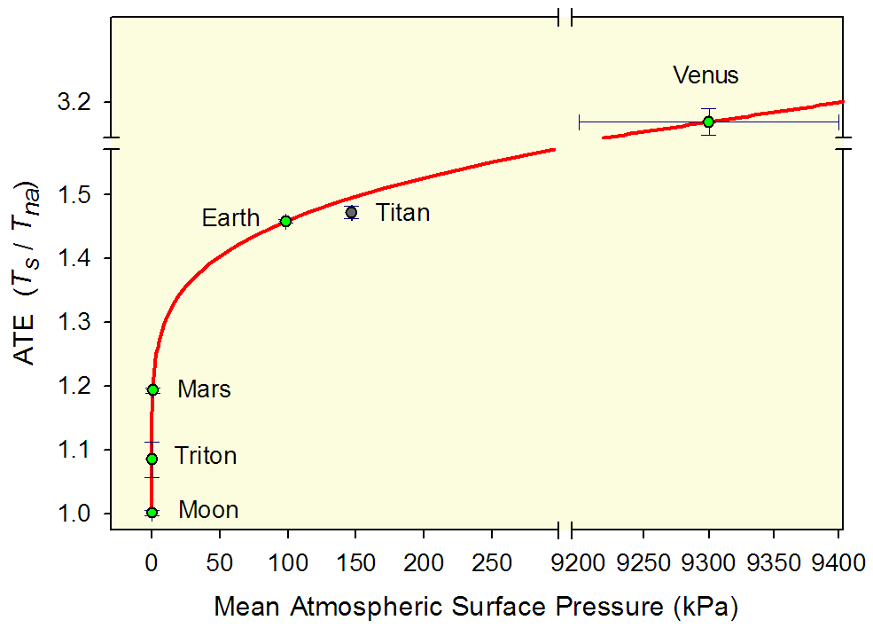
Figure: On this graph, is the observed equilibrium global surface temperature of a planetary body, while is the body’s mean global surface temperature in the absence of an atmosphere. The ratio shown on the vertical axis represents the Atmospheric Thermal Effect (ATE) of a planet or moon also known as the Natural Greenhouse Effect. The graph implies that the background thermal effect (i.e. the ‘greenhouse effect’) of a planetary atmosphere is only a function of the total air pressure and does not depend on the atmospheric chemical composition. In other words, the Greenhouse Effect is physically a pressure-induced thermal enhancement (PTE), not a radiative phenomenon driven by heat-absorbing gases as currently believed. Hence, carbon emissions cannot affect the global climate. The sensitivity of Earth’s climate to CO₂ is virtually zero!

Some 500 years ago, Copernicus simplified the complicated model describing planetary retrogressions by conceptually observing Earth from afar. The study by Nikolov and Zeller (2017) simplifies the understanding of the physics of climate by taking a similar broad extra-terrestrial perspective. Their findings also provide new insight as to why the IPCC-supported Global Climate Models (GCMs) based on the radiative Greenhouse concept fail to predict observed global temperature trends, hence should not be used for policy decision making.

References:

Nikolov N, Zeller K (2017) New insights on the physical nature of the atmospheric greenhouse effect deduced from an empirical planetary temperature model. EPCC, 2:2, in press.

Volokin D, ReLlez L (2014) On the average temperature of airless spherical bodies and the magnitude of Earth's atmospheric thermal effect. SpringerPlus 3:723, doi:10.1186/2193-1801-3-723.

NB: Volokin and ReLlez are pseudonyms for Nikolov and Zeller

